RESOLUTION NO.__________

RE: CERTIFICATE OF APPROPRIATENESS UNDER THE
PROVISIONS OF THE ACT OF THE PENNSYLVANIA
LEGISLATURE 1961, JUNE 13, P.L. 282 (53
SECTION 8004) AND BETHLEHEM ORDINANCE NO.
3952 AS AMENDED.

WHEREAS, it is proposed to paint the entire exterior of the rear structure at 245 E. Church St.

NOW, THEREFORE, BE IT RESOLVED by the Council of the City of Bethlehem that a Certificate of Appropriateness is hereby granted for the proposal.

Sponsored by: (s)

(s)

ADOPTED BY COUNCIL THIS DAY OF

(s)
President of Council

ATTEST:

(s)
City Clerk

HISTORICAL & ARCHITECTURAL REVIEW BOARD

The applicant is proposing to paint the entire exterior of the rear structure at 245 E. Church St.
APPLICATION #1:

Gregory T. Horwath
24 E. Broad St.
Bethlehem, PA 18018

OWNER:

__________________________________________________________________

The Board upon motion by Marsha Fritz and seconded by Phil Roeder adopted the proposal that City Council issue a Certificate of Appropriateness for the following:

1. Paint the entire exterior of the rear building including gutters, eaves,
windows, doors, porch, walls & garage doors.

2. The Historic colors will be from the Martin-Senour Williamsburg Collection.

3. The color scheme will be:
Brick/Block: James Geddy Green #W1075
Pedestrian Doors: Palace Arms Red #W1083 PKG
Wood Trim: Blue Bell Tavern Gray Green #W1249
Garage Doors: Courthouse White
Soffit: To match wood trim

4. Existing window in the north wall will receive a new sill and wood head trim
painted to match the window with infill wood painted James Geddy Green.

5. Cupola walls and door to be painted James Geddy Green and the trim to be
painted Blue Bell Tavern Gray.

6. The motion was unanimously approved.
__________________________________________________________________________

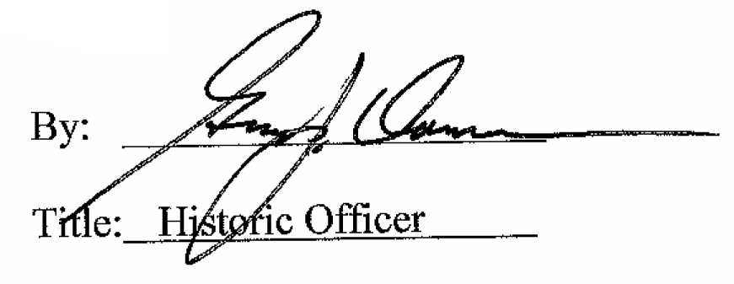

Date of Meeting: July 6, 2016

